Milestone 2

Contents :

- Storyboard Presentation

- Wireframe Presentation

**STORYBOARD** Presentation

What’s a storyboard?

• A storyboard is a visual representation used to organize a sequence of images and illustrations to tell a story or present a process.

• With this storyboard I have tried to map out the user journey, from initial engagement through various steps of interaction, to the final outcome or goal.

• Hoping that this technique will help my team to visualize the user experience, identify potential issues, and refine the design before actual development begins.

Encounter with a Problem 

• Meet Alex, a student at IITM.

• Alex is in a study room, attempting to find a solution to his problem.

• Encounters an issue - an error occurs. • He is stuck with no solution in sight • To find a solution he uses our app

Avoiding Duplicate Efforts 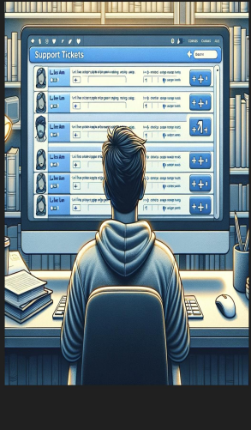

• Our app suggests similar existing tickets to Alex.

• Encourages +1 on existing tickets to prioritize them.

• Thus reduces duplicate tickets, streamlining the support process.

Fortunately or Unfortunately….. 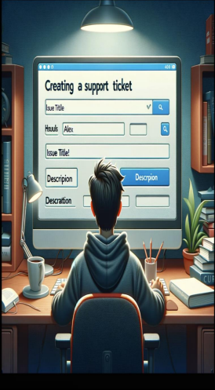

• Alex could not find any similar tickets therefore created a new one.

• He could also generate a discourse thread. • Thus a detailed discussion on this issue was facilitated

Engaging the community 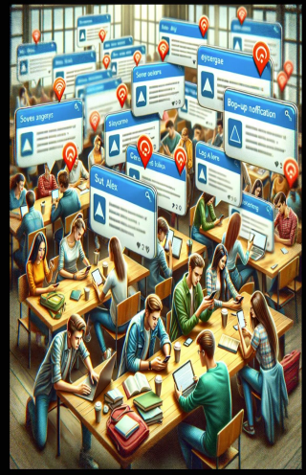

• All Alex’s friends received the notification for a new thread created by Alex.

• Encouraged active participation in the resolution process.

• Made the issue and it’s discussion accessible to others

Alerting the authorities 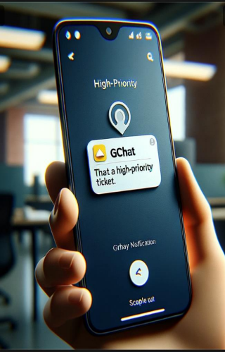

• +1s of the students has set things into action.

• The issue has been set for immediate action.

• Demonstrating efficient use of webhooks for escalation

Prioritizing student concerns 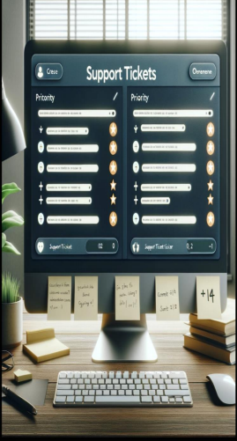

• Tickets are prioritized by student’s +1s. • Acting on this support staff takes notice for prompt action.

• Streamlines support efforts towards pressing issues

Sharing solutions 

• After addressing the ticket, support staff makes the ticket publicly accessible.

• Encourages a culture of shared understanding.

Problem solved 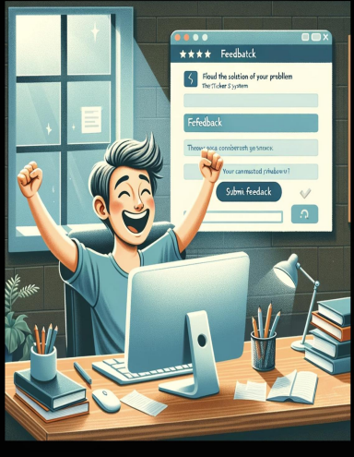

• **Notification Received**: Alex is informed of the ticket resolution. • **Satisfaction**: Addresses the initial concern, closing the loop. • **Feedback Opportunity**: Prompt for Alex to provide feedback on the support received.

Continuous improvement 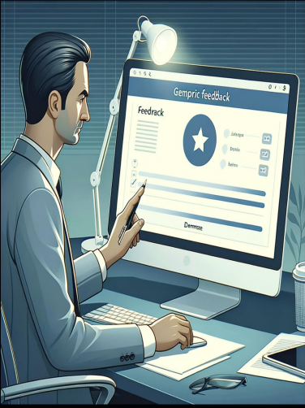

• **Insight Gathering**: Review of student feedback for actionable insights.

• **Process Optimization**: Identifies areas for training and process enhancement. • **Commitment to Excellence**:

Underscores the ongoing effort to improve student support.

**WIREFRAME** Presentation

What’s a wireframe?

• A wireframe is a simplified visual guide that represents the skeletal framework of a website, application, or software interface.

• Wireframes are critical in the user interface (UI) design process because they help stakeholders and team members understand how users will interact with the product, where elements will be located, and how the overall navigation will be structured.

Student’s Perspective

Search for a ticket Search Logo Create ticket Discourse Forum 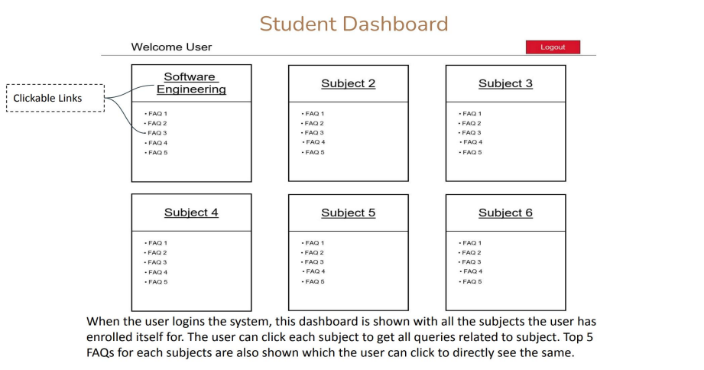

More… More…

More…

Also the

student on

his/her arrival will be greeted by the app and

can navigate through the app using the buttons added on the

navigation bar

More… More…

More…

Filters: Resolved In Progress Open All 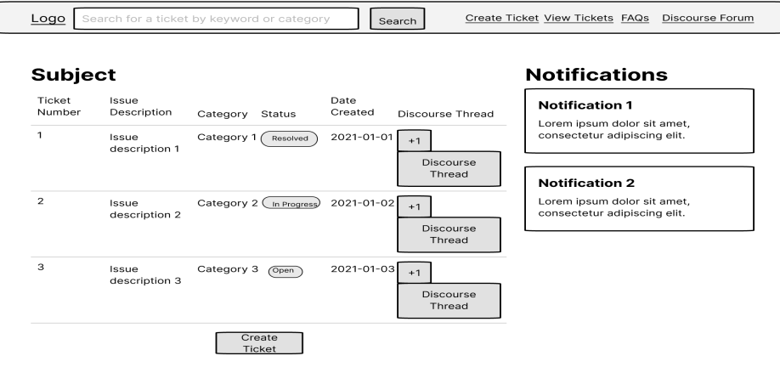

When clicked on any subject in the dashboard…..

And student can see discourse thread corresponding to each ticket and can +1 tickets of different students when clicked on view tickets student can see tickets created by him/her and for every new updates regarding his/her ticket a notification will be sent

**FAQ** When Clicked on FAQ or More… this section will open up

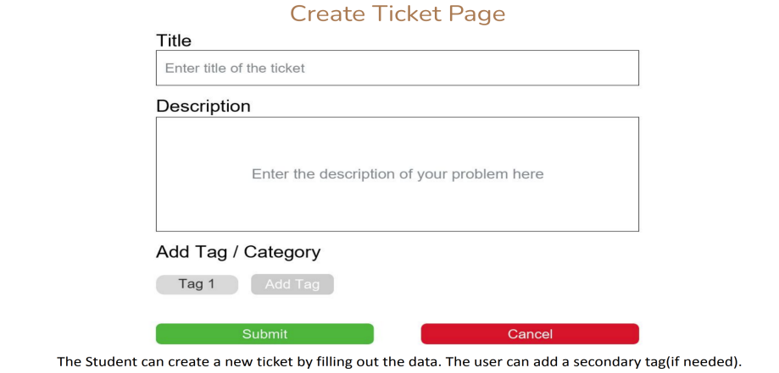On Discourse The student can post the tickets directly to Discourse

too other than putting it on the app

Ticket View 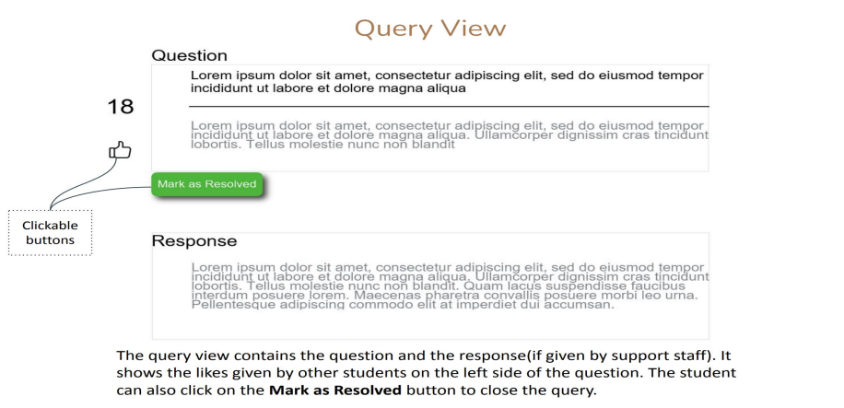

Go to Discourse Write a review

Reading the response student can write a review for the corresponding response directly to the staff.

Review Page

The student can post the tickets directly to Discourse too.

On Discourse

Support staff’s perspective

**My Reviews**

Support staff will get high priority alert on Gchat and he/she can also solve it or make the query public for the Gchat alert support staff can directly address to the concern party on google chat too 

Support staff can read reviews that a student has written for the course corresponding to him

Admin’s perspective

Filters: Resolved In Progress Open All 

Mark FAQ

FAQ

Resolved Resolved

FAQ FAQ

Admin Can mark Solved tickets as FAQ thus the tickets will reflect in FAQ section



Based on number of +1s of a ticket priority will get updated and admin will have option to send a Gchat to corresponding course instructor

**THANKYOU**